Algorithms and Codes

Abstract
This document introduces several versions of algorithms and codes used in two controllers:
- Arduino
- AT90PWM3B

Arduino

Digital Output Comparison
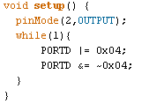
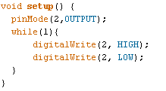
Arduino has a buit-in funcion digtalWrite(Port, State) for digital output. However, it may not be as efficient as directly setting the register in the AVR controller. The efficiencies are investigated by measuring execution time of each command

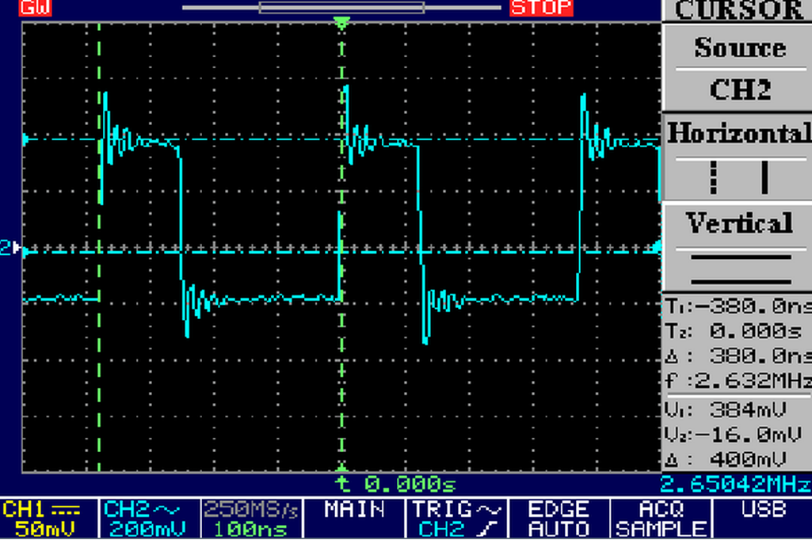
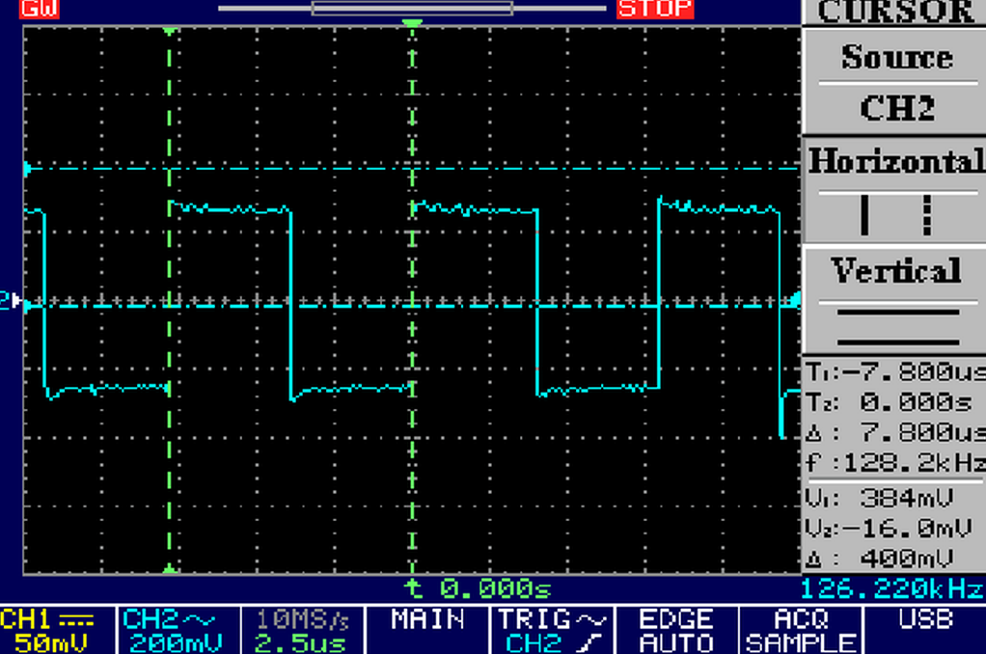

As can be seen from the graph, the execution time of digitalWrite() is 7.8/2 = 3.9 us. The execution time of setting PORTD register is 380 ns/2 = 190 ns, which is 20.53 times the execution time of digitalWrite().
Therefore, we can conclude that setting PORTD register is much more efficient than using digitalWrite().

Measurements | Execution Time (us)
Two A/D Conversion | 33.3 us
60 Digital IO * 10 | 7.80 us * 10 = 78 us
Control Code

Two A/D Conversion
The system clock is set by the external 16 MHz crystal.
Each normal A/D conversion takes 13 cycles following a typical sample and hold cycle of 1.5. In addition, it takes 25 ADC clock cycles for the ADC to initialize.
The ADC accuracy depends on the ADC clock. According to [1], the ADC clock frequency can be up to 1 MHz without compromising the 10-bit ADC resolution. Therefore, the prescaler needs to be 16 for a 16 MHz crystal to obtain a 1 MHz ADC clock.
For a typical conversion of 14.5 cycles, the theoretical execution time is
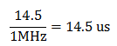

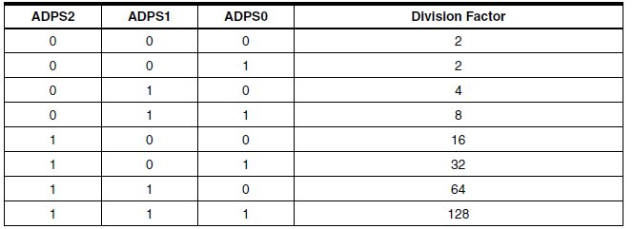

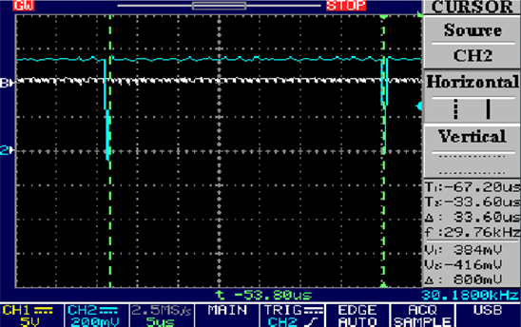

The measured time is 33.6us, which includes one execution that sets I/O high. The actual execution time of two analogueWrite() is thus 33.6- 0.3= 33.3 us.
(For one analogueWrite, the execution time is measured to be 16.6 us)
The Arduino function analogueWrite() also contains several other commands. These commands contribute to the discrepancy between the measured value and the theoretical value.

60 Digital IO
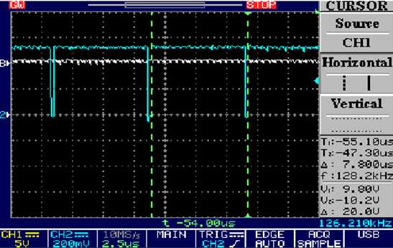

The measured time is 7.80 us for 60 writes to PORTD.

Using data type double or float significantly increases execution time as retrieving a double type data needs reading two memory locations.
Multiply double values by 100 to convert them into int values.

Appendices

Appendix I

Reference
[1] Application note AVR120: Characterization and Calibration of the ADC on an AVR

